Project Name: Catchy (Personal Assistant)

Available on Github: <https://github.com/Virksaabnavjot/Catchy>

Name: Navjot Singh Virk

Student Number: x13112406

Stream: Software Development

Submitted to: Dr Dominic Carr

**Introduction**

The aim of this document is to define the purpose of my application and to What degree the requirement for the project were satisfied.

**Purpose of the Project**

The purpose of the project is to create an easy to use i.e. user friendly android application that act as a personal assistant and provides features like showing the users current location (coordinates), take photos using camera, able to make calls using the app and create Items for Grocery and view them in a list.

**What Degree you have satisfied the requirements of the project?**

The project was challenging and a lot of fun and I have learned a lot of new things about android after this project.

*Below is the list of requirements and how they were met –*

1. At least three activities

The application has more than 3 activities and the main activity has buttons to launch other activities (have used both implicit and explicit intents).

1. UI

User Interface/GUI of the application is done using XML and keeping best practices in mind along with judicious use of android layouts (Linear).

1. Interactive

The app has edit texts & text views, image view and buttons in multiple activities for user interaction + slider (UI Widget).

**Advanced Features (Any two)**

The application incorporates 3 advanced features -

1. Camera – allows the user to take images and display it in an image view.
2. Telephony – allows the user to make calls through an intent.
3. Animation – animation b/w activities.

**Bonus Features (Any two or more)**

1. Location – show users current location i.e. co-ordinates
2. Local Database – SQLite allow the user to store Item name and number and then list all the entries available in the database

Evaluation

The project was challenging and complex to implement at different stages during the development of the project. I believe to the best of my knowledge, I have completed the app well & met all the requirements and it can be a useful application and I could use it myself or consider for further development.

There was an active attempt to use best practices –

1. The code is commented where necessary
2. The code is referenced if used from external source.
3. Attempt to give variables meaning full names to make code more readable.
4. Separation of Concerns in code and UI.
5. Attempt to do proper usage of android life cycle.
6. Well formatted code.

**Android Activity Lifecycle Diagram**

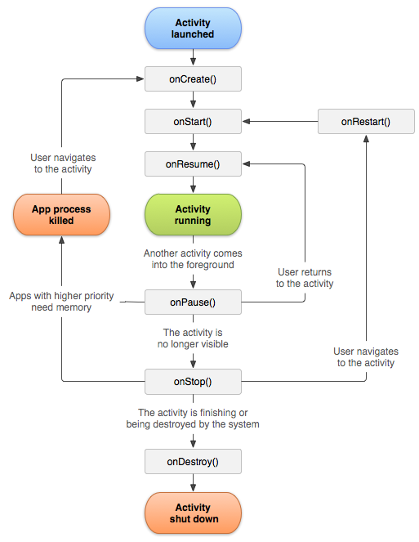

**Image Source:** [**https://developer.android.com/guide/components/activities.html**](https://developer.android.com/guide/components/activities.html)

I hereby declare the above work and the submitted code is my own work and if some code is taken from external resources it has been referenced and the project may contain code snippets from the examples available on moodle.

Signature: Navjot Singh Virk

Dated: 23RD December 2016